Foundation for Virtual and Augmented Reality Systems
Prof. Samit Bhattacharya
Department of Computer Science and Engineering
Indian Institute of Technology, Guwahati
Week – 05
Lecture – 26
Lec-26: Human Factors in XR
Hello and welcome to the NPTEL MOOC's course on Foundations of Virtual and Augmented Reality Systems. We are currently discussing human factors in XR as part of lecture topic number 13. So, we will continue our discussion on this topic. In the previous part of the lecture, we learned about the basic idea of the role of human factors and the idea of perceptual psychology, why we should know it, and what are the components to understand our perceptual process.
So there are broadly two things that we touched upon. One is the physiology of perception; the second thing is the process. So in the previous part, we talked about physiology primarily, the sensory organs, and the receptors. In this part of the lecture, we are going to talk about the process of perception, how our perception works.
So, from sensing to perception. Sensing is the lowest level. From there, how we reach perception, which is at a very abstract level. As is obvious, perception happens after sense organs convert stimuli to neural impulses.
So, first sense organs get stimulated with the particular type of stimuli and then they convert that input stimuli into neural impulses. After that happens only then can we say that we should be able to perceive things. One interesting statistic here is that we have around 86 billion neurons there in our brain. Now, that is a very big number of course as you can understand. Out of these 86 billion approximately neurons, roughly 20 billion are devoted to the cerebral cortex, that is the part of the brain that handles perception and other functions like attention, memory, language, and consciousness. So, the cerebral cortex part is responsible for perception. Perception is a higher level activity and roughly 20 billion neurons are devoted to this task along with some other activities. There is in fact a large sheet of neurons around 3 millimeters thick that is heavily folded to fit into the skull. So, we can think of it as a kind of folded sheet of neurons and this thickness of the folded sheet is around 3 millimeters.
So, this entire sheet contains almost 86 billion neurons. Now there is something called interconnection of neurons. So this perception and overall cognitive ability, which includes other activities as well, depends on such interconnection between neurons. Now let us try to understand this thing with the help of this schematic of a neuron. So we have a neuron here which has a nucleus.
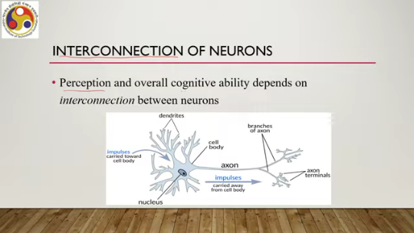
Then some parts called dendrites, axon terminals, and branches of axon. So, this part is the axon, then we have branches and terminals. Impulses are carried forward, carried toward the cell body. So, neural impulses are the input here, then get transmitted to toward the output side. So, impulses are carried away from the cell body.
So, we can think of this interconnection of neurons as an enormous directed graph or network which is actually the original idea behind the neural network used in machine learning or deep learning approaches. So, we have a nucleus or cell body, which we can consider to be a node in the graph, and this cell body can be thought of as doing some kind of processing on the input. The dendrites are input edges to the node.
So, this is the cell body node, these are the input edges, these dendrites are the input edges and axons are the axon here are the output edges. So, starting from here, we can think of this to be the node, this is the input, and this is the output for each node. Through the network of dendrites, neurons can aggregate information from other neurons. So, whatever information comes from other neurons can reach the nucleus of a given neuron through the input edges, that is the dendrites, which themselves may have been aggregated by other neurons. So the input that is coming to a neuron may be aggregated in itself, aggregated information from others.
The result is sent to one or more neurons through axons. So whatever little processing takes place in the node gets transmitted to other neurons through the axons or the output edges. Now for a connected axon dendrite pair, note that for interconnection we need to connect axon of a neuron to the dendrite of the next neuron. Now for a connected axon dendrite pair, communication occurs in a gap called the synapse. In other words, the axons and dendrites of the next neuron.
are not physically connected; there is a gap in between which is called the synapse. Through this gap, electrical or chemical signals are passed along by some means rather than having a physical connection between axons and dendrites. Now each neuron in the human brain has on an average about seven thousand synaptic connections to other neurons, which results in about 10 to the power 15 edges in our brain graph, and you can assume how big the number is. You can understand how big the number is: 10 to the power 15.
It is a huge number. So, that is how complex our neural network in the brain is. Now there is something in this neural processing that is called hierarchical processing. From sense organ receptors, signals propagate through the neural network to eventually reach the cerebral cortex. Along the way, hierarchical processing is performed.
Through selectivity, Each receptor responds to a narrow range of stimuli across time. We have already talked about the idea of selectivity, that is, each receptor is susceptible to only one kind of stimulus. So, each receptor responds to a narrow range of stimuli across time, space, frequency, and so on. Now, after passing through several neurons, signals from numerous receptors of different types are simultaneously taken into account. So, when we are utilizing the neural connections, then, of course, different receptor inputs are coming to the cerebral cortex through these connections. So, there these different inputs are combined. It allows increasingly complex patterns to be detected in the stimulus. So, it works in stages.
So, first level, one level of aggregation, then next level, another higher level of aggregation, then another level on top, a third level of aggregation and so on till it reaches the human brain that is the cerebral cortex part of the brain. So, that type of processing that is called hierarchical processing allows increasingly complex patterns to be detected in the stimulus. So, the idea can be understood in this way.
Suppose these are the receptors R1, R2, R3. So, the inputs from the receptors go through, say, here. Then there can be R4; these two go through here. So, they get combined. So, neuron 1, neuron 2, then these two.
So, neuron 1 aggregates from R1 and R2; neuron 2 aggregates from R3 and R4; then this aggregated information is passed on to, say, another neuron N3. Now, this aggregated information is not the same as the information from R1 and R2 or R3 and R4, the lower-level information. So, they are slightly higher level as compared to the lower-level information. Similarly, when they get aggregated in N3, another higher-level information is obtained.
So, this is the hierarchical processing. In hierarchy, the processing takes place until it reaches the cerebral cortex. So, this allows, as the idea clearly illustrates. This allows increasingly complex patterns to be detected in the stimulus. That is the advantage of this hierarchical processing for which our brain is already designed.
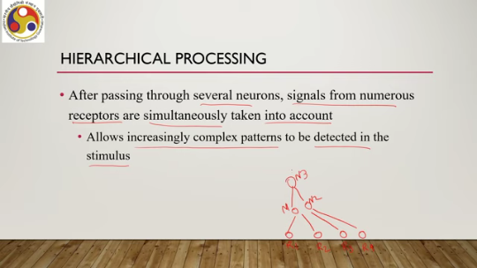
Once in the cerebral cortex, sensory signals are combined with life experience or knowledge stored in long-term memory for interpretation of stimuli. So, there are two things. One is input from stimuli that is real-time information plus we have knowledge. in long-term memory, which can also be called experience gained over a long period of time, learned over a long period of time.
These two are combined to give us the interpretation of the stimuli. So, stimuli interpretation is not based on only the sensory inputs; it also depends on what kind of real-life experience knowledge we have. So, the way someone with less experience say for example, a newborn child interprets a stimulus and the way someone with long experience such as an aged person interprets a stimulus, they are very different.
Now, this combination together results in perceptual phenomena, that is face recognition, identification of a song, and so on. So, if we never heard of what is a song, we do not know the rhythm of music that is an experience, then we cannot interpret the corresponding sound wave as music unless we have a knowledge of what music is. Similarly, unless we know what is a face, so when the stimuli or eye receives the signal that is only light patterns, But then converting it to face, we need to have some idea of what a face is, whether it is a human face or animal face.
So, this type of knowledge, this type of experience, gets combined with the raw stimuli that comes to our body through sensory organs and then only we are able to do the perception. So, the overall perceptual processing is an outcome of the hierarchical processing plus combination of real-time sensory input with our long-term knowledge or experience. That is how we perceive things. Now, there is another aspect of our perception that is called proprioception. This is slightly different than direct perceptions with sensory organs, say for example, vision, auditory sense, touch, smell, taste. Now, along with sensory information, we also use proprioception. This is the ability to sense relative positions of the body parts and the amount of muscular effort involved in moving them. For that, there is no direct sensory organ; from different sources, different bodily parts, we infer about these things.
Information is sent by the motor cortex, which controls body motion. Now motor cortex sends signals which are called efference copies. to other parts of the brain to communicate what motions have been executed. And it also sends the signal to the cerebral cortex part, along with other parts of the brain. So, it is essentially another kind of sense, although without any specific sensory organ or receptor.
So, without any specific sense organ or receptor. we can call it to be a sixth sense. So, often you probably have heard of this sixth sense term. So, typically we associate our body with five senses. Now, this we can call to be the true sixth sense, where we do not have a dedicated sensory organ or dedicated receptors to receive the stimuli, but we get some of the information and do some processing on the information sent by motor cortex to understand the relative positions of our body parts and the amount of muscular effort required to move them. So, what is the implication of having all this knowledge of proprioception or the sixth sense as well as the other senses and the process the physiology, what are the implications, how they can help. Let us have a quick look. Later on, we will elaborate on this in other lectures.
So, what this entire knowledge tells us is that we get signals from multiple senses and proprioception. We process it; it is clear. We combine it with our experiences, which are obtained over the years over a very long period of time that is our learning. Now our brain interprets these combinations of inputs in coherent, consistent, and familiar ways and these ways are learned over a long period of time.
So, when we say brain development that is basically learning this process of perception, learning the process of cognition over a long period of time. Now any attempt to interfere with these operations is likely to cause mismatch among the data from our senses. The brain may react in a variety of ways as we have already seen. So, the brain has learned how to process information from our sensory organs over a long period and it has adapted to follow that process. Now, if we are trying to understand things in a different way overnight, certainly that is not going to happen.
Again, we have to retune our brain over a long period of time. But when we are trying to experience an immersive system, a VR system, we do not have that long period of time to experience it. Instead, we are trying to experience it in a very short span of time. So, clearly there is a mismatch. For some people, that mismatch may not be very significant because their brain can adapt to it. For others, it may become a significant issue leading to cyber sickness and other such effects. So, if we are unable to learn or rather relearn how to process the sensory organs given a virtual reality system context, then we may become fatigued or develop headache which is a symptom of cyber sickness. We could develop symptoms of dizziness or nausea, again cyber sickness.
The brain may make us consciously aware of the conflict. We immediately understand the experience is artificial. We immediately understand the experience is artificial. In that case, we lose presence. So presence is compromised.
So these are some of the possible effects that may result in this mismatch between what the brain gets and how the brain processes in a familiar way. An example of this is Vection, which is an illusion of self-motion. Moving in a virtual world, virtual environment, while we are not physically moving, we are sitting or standing somewhere. So in that case, the visual input that is coming from the virtual environment, vision in that case, that vision sense reports to the brain that we are moving or accelerating, whereas your balance sense or proprioception tells that we are motionless. So there is a sensory conflict here. Vision tells something, balance sense, proprioception tells something else.
And if the brain is able to adjust to this mismatch, good. In many cases, it may not be able to do so. Then we can feel cybersickness or our presence will be compromised. We will immediately be aware of this thing. that we are in an artificial different world rather than a natural or real world.
So, we have to be very careful while designing extended reality. The goal should be to balance experiences by various senses. To give an immersive experience by fooling our brain in a way such that the brain is able to process the information in the way we want. Now, of course, this is not an easy thing.
We have to put in a lot of effort in design, in deployment, in understanding the users, in choosing the right hardware depending on the user's abilities. So, many things, many factors are there as we have already covered when we discussed cyber sickness or other issues and challenges. So in summary, what we can say is that we got in this lecture an overview of human physiology and the process of perception in the context of designing VR systems. So we learned the basics of human physiology, human psychology, perceptual psychology, so to speak, and then the components, namely the physiology and the process. And also, we briefly touched on how they are how that knowledge can influence the overall design of the system, how it can help us raise questions and answer those questions, both from the point of view of a system as well as the human user. So, in the next few lectures, we will cover various sensory organs, their workings and implications for system design. extended reality system design in particular in a little more detail. Here, of course, we have covered all the sensory organs, but at a very superficial level. Subsequently, we will go into a little bit more detail on each of the organs, sensory organs that we have talked about here and how that knowledge will be relevant for building XR systems.
So the material of this lecture can be found in this book by LaValle, Virtual Reality. Most of the material is taken from this book. So with that, we have come to the end of this part of the lecture, and we have finished our discussion on the topic. Looking forward to meeting you in the next lecture. I hope you have understood the concepts, and you have
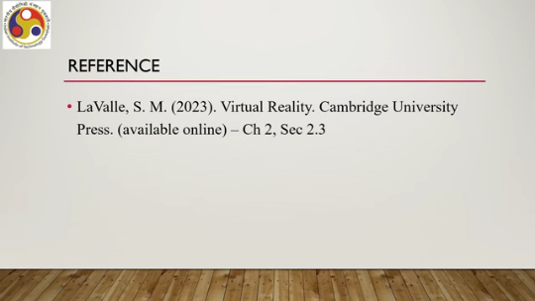
Enjoyed it? So looking forward to meeting you in the next lecture. Till then, thank you, goodbye, and happy learning.

